**Custom Jira Plugin Development**

**Table of Contents**

|  |  |
| --- | --- |
| Topics | Page Number |
| Atlassian – SDK Installation | 1-2 |
| Baseline Atlassian Structure | 2-4 |
| Uploading Custom Hello-world plugin to Jira | 5 |
| Updating Plugin module | 6-8 |
| Dependency pom.xml/Integration tests | 9-10 |
| Atlassian commands/Outputs | 10-11 |
| Connectivity check – Gitlab and Jira | 12-13 |

**Atlassian – SDK Installation**

Install the Atlassian SDK on your windows and check the version whether it is properly installed.

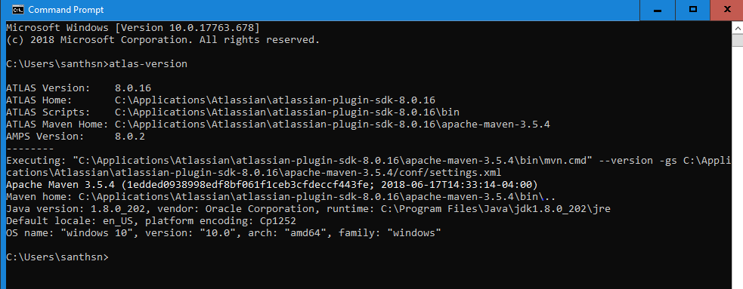

Use the Atlassian SDK to build a Skeleton by the following command

atlas-create-jira-plugin

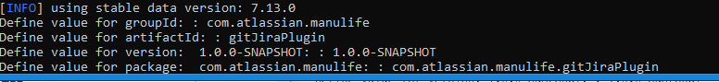

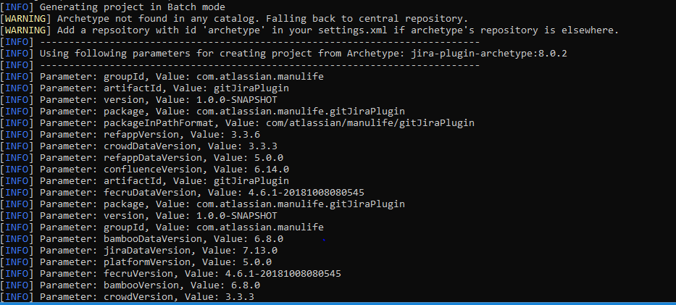

Base structure will be created in below format

1. ├── LICENSE
2. ├── README
3. ├── pom.xml
4. └── src
5. ├── main
6. │ ├── java
7. │ │ └── com
8. │ │ └── atlassian
9. │ │ └── tutorial
10. │ │ └── myPlugin
11. │ │ ├── api
12. │ │ │ └── MyPluginComponent.java
13. │ │ └── impl
14. │ │ └── MyPluginComponentImpl.java
15. │ └── resources
16. │ ├── META-INF
17. │ │ └── spring
18. │ │ └── plugin-context.xml
19. │ ├── atlassian-plugin.xml
20. │ ├── css
21. │ │ └── myPlugin.css
22. │ ├── images
23. │ │ ├── pluginIcon.png
24. │ │ └── pluginLogo.png
25. │ ├── myPlugin.properties
26. │ └── js
27. │ └── myPlugin.js
28. └── test
29. ├── java
30. │ ├── it
31. │ │ └── com
32. │ │ └── atlassian
33. │ │ └── tutorial
34. │ │ └── myPlugin
35. │ │ └── MyComponentWiredTest.java
36. │ └── ut
37. │ └── com
38. │ └── atlassian
39. │ └── tutorial
40. │ └── myPlugin
41. │ └── MyComponentUnitTest.java
42. └── resources

└── atlassian-plugin.xml

Use atlas-run command to run the application and install the plugin

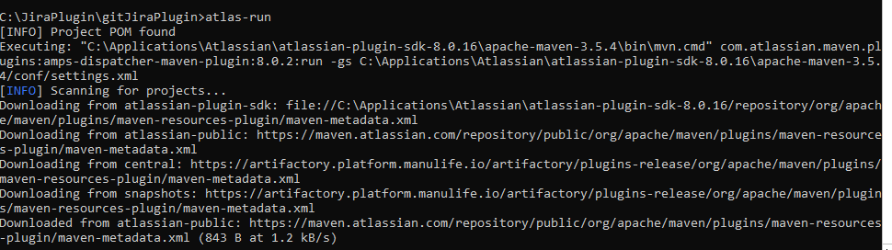

Then login into Jira and create new user as Dhanvannth

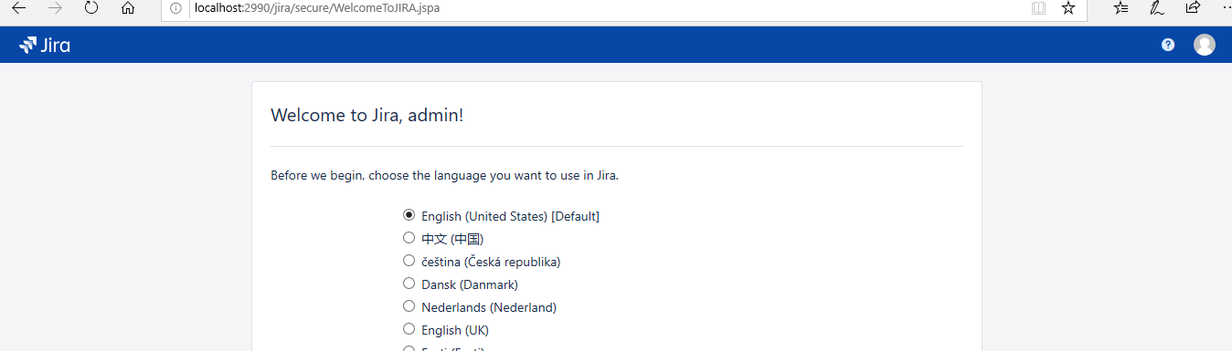

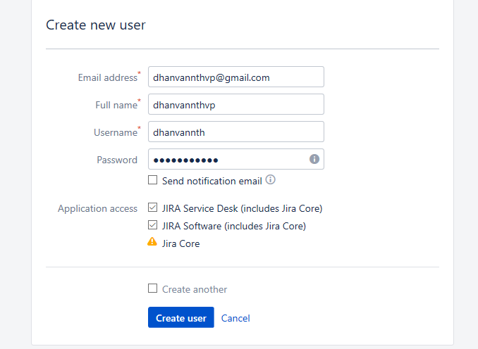

Then login as admin and upload your Hello-world plugin.

Jira URL : localhost:2990/jira/secure/Dashboard.jspa

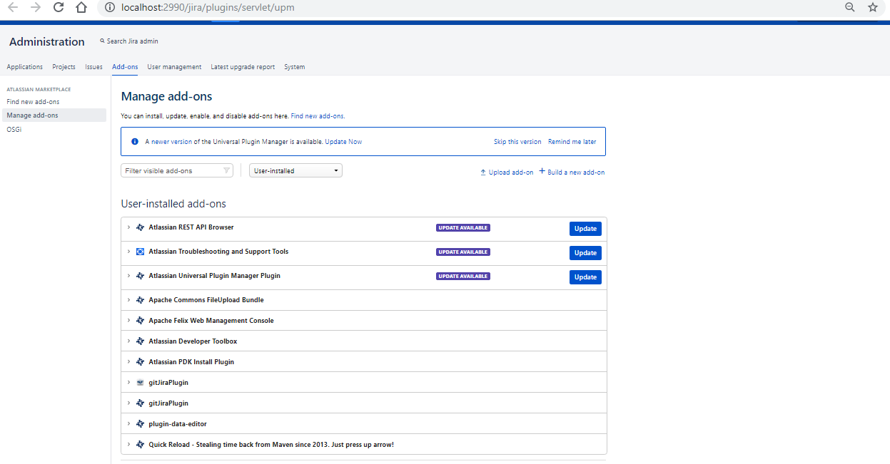

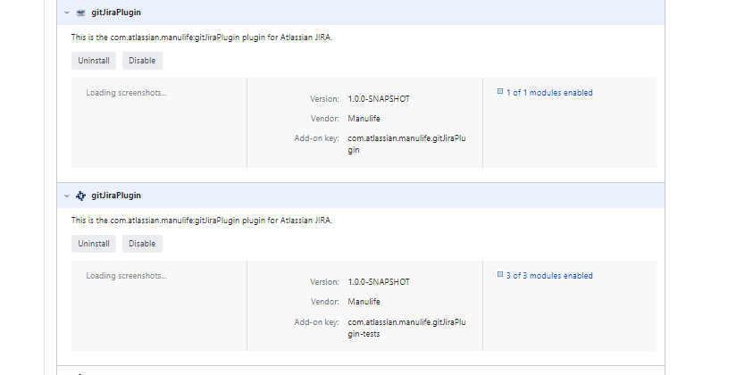

And you are able to see your changes in Jira.

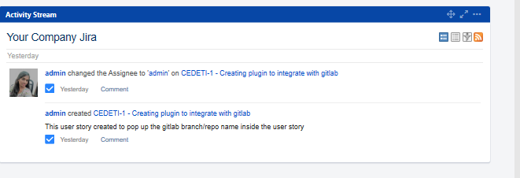

If you want to modify the plugin and needs to add any new item/menu/websection in jira, use the below command to select the right option

1. atlas-create-jira-plugin-module

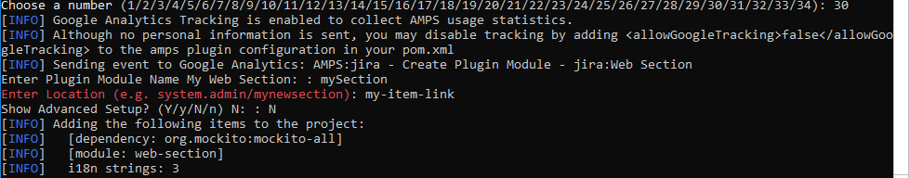

Enter Plugin Module Name My Web Section: : mySection

Enter Location (e.g. system.admin/mynewsection): my-item-link

Show Advanced Setup? (Y/y/N/n) N: : N

1. Next, you're prompted to enter another plugin module. Type **Y** to create another module.
2. Type **25** to select the Web Item plugin module and then answer the configuration questions as follows:

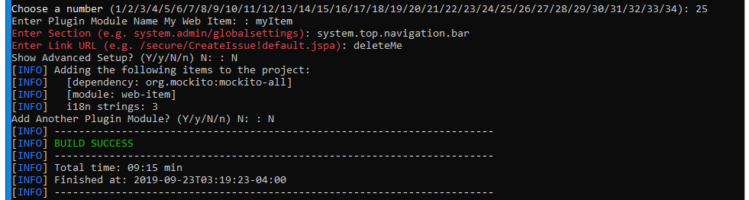

**C:\JiraPlugin\gitJiraPlugin\src\main\resources -> Atlassian-plugin.xml**

<http://localhost:2990/jira/browse/CEDETI-1> - Userstory details

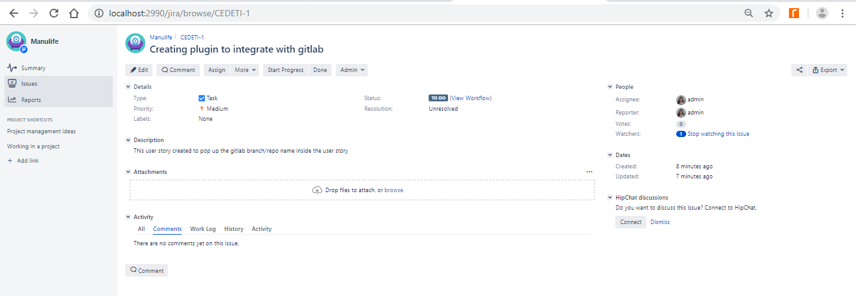

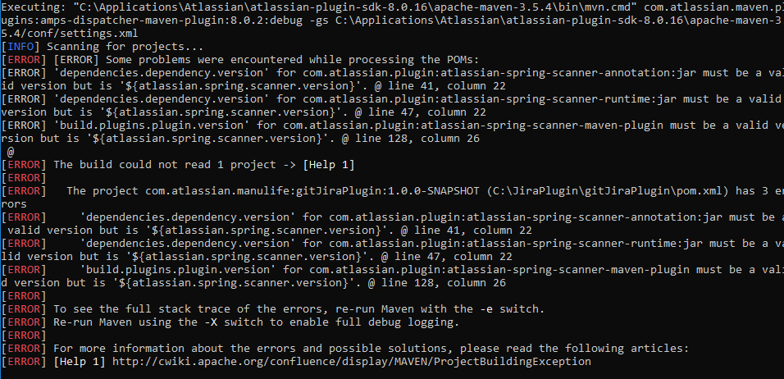

Run atlas-mvn eclipse:eclipse should be run in the plugin directory, where the pom.xml should be ;-)

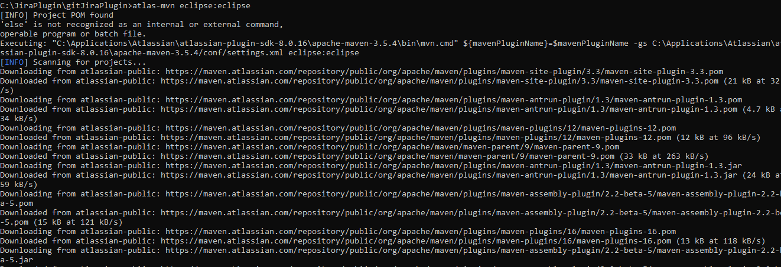

**Pom.xml**



Checking Integration-test

**C:\JiraPlugin\gitJiraPlugin>atlas-integration-test**

**[INFO] Project POM found**

**Executing: "C:\Applications\Atlassian\atlassian-plugin-sdk-8.0.16\apache-maven-3.5.4\bin\mvn.cmd" com.atlassian.maven.plugins:amps-maven-plugin:8.0.2:integration-test -gs C:\Applications\Atlassian\atlassian-plugin-sdk-8.0.16\apache-maven-3.5.4/conf/settings.xml**

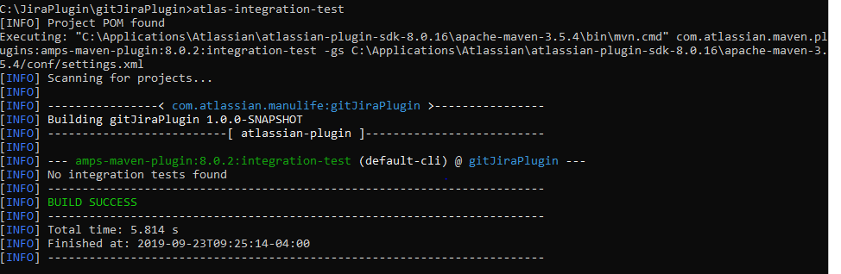

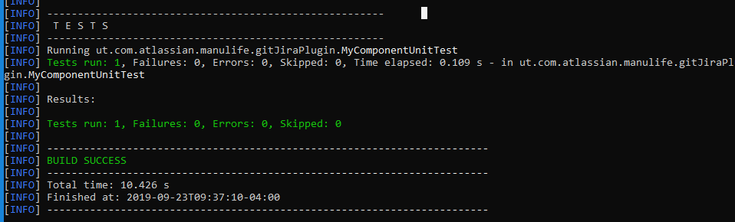

**Atlassian Commands**

mvn eclipse:eclipse

mvn eclipse:clean **if you want old settings to be removed.**

**Ctrl-C to shutdown gracefully**

**Ctrl-Z to quit**

**Atlas-debug**

**Atlas-clean**

**Eclipse Console**

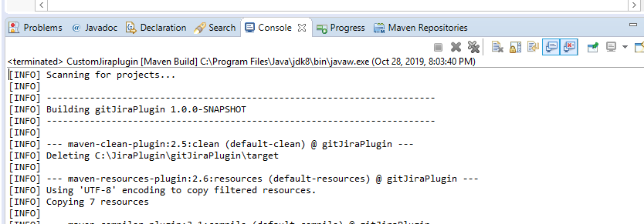

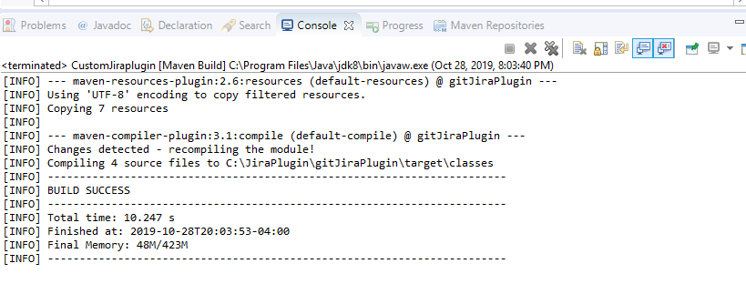

**Clean Install**

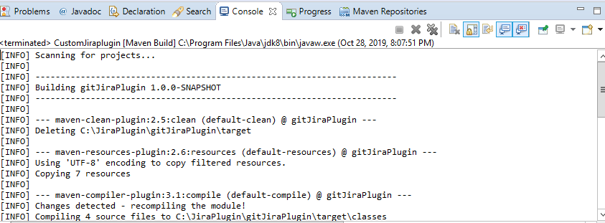

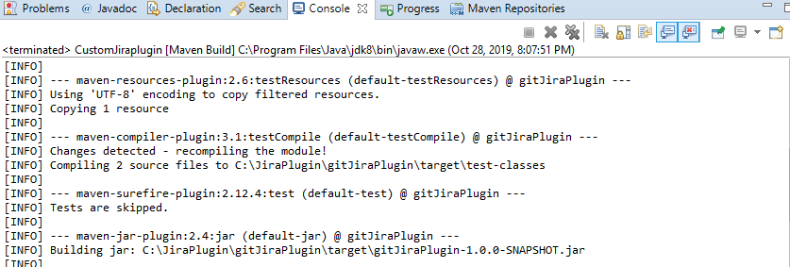

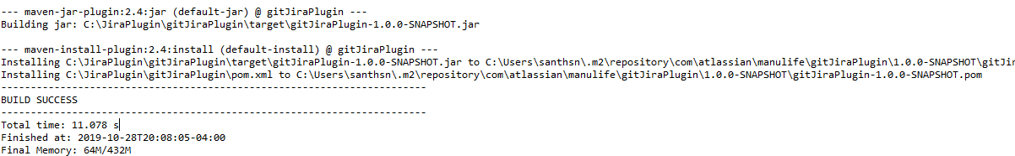



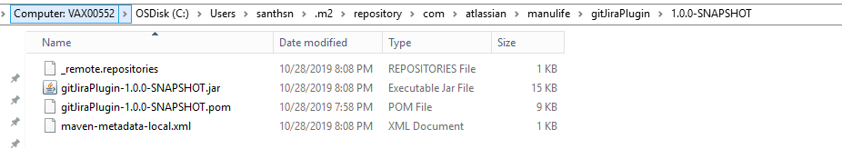

**Gitlab Connectivity**





**Jira Prod Connectivithy**



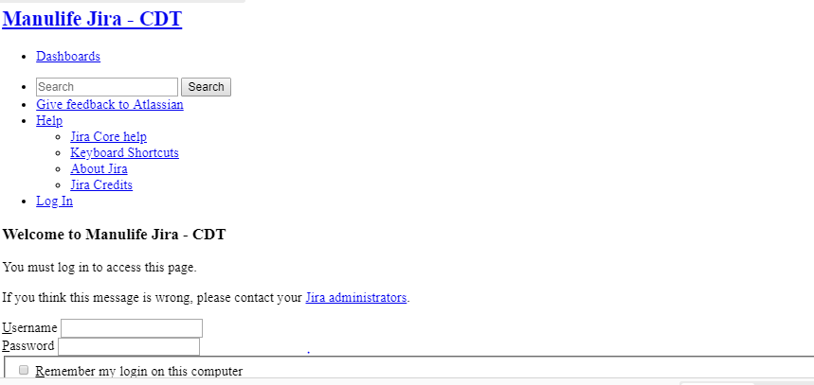

**Proposal:**

**Need to check the connectivity by reaching out to Gitlab-Prod**